COLLEGE BUSINESS EDUCATION
Dar es Salaam

INDIVIDUAL ASSIGNMENT
COURSE: BACHELOR DEGREE IN INFORMATION TECHINOLOGY.
MODULE: PROGARAMMING in JAVA
MODULE CODE: ITU07312
FACILITATOR: Dr. AHMED KIJAZI
YEAR OF STUDY: Second Year
SEMESTER : 1st
ACADEMIC YEAR: 2025/2026
STUDENT NAME: Regina Charles
REGISTRATION NUMBER: 03.4512.02.01.2024
STREAM: TNC
Deadline Date: 2026-01-06

1. a). SWING
A graphical user interface (GUI) tool for creating objects, buttons, scroll bars, and windows. The GUI classes in javax.swing, together with the foundational classes in java.awt, are all part of the API that makes it possible to program graphical user interfaces in Java. Swing was included as part of the Java Foundation Classes (JFC).

  - With diagrams, explain the Java Swing components
i. Top-Level Containers
These are the windows that exist independently on your screen. They are not contained within any other component.
- JFrame: The main window with a title, border, and buttons (minimize, maximize, close). It serves as the "root" for most desktop applications.
- JDialog: A pop-up window or secondary window used for messages or user input.
- JApplet: Used for creating Java programs that run within a web browser (now largely deprecated).
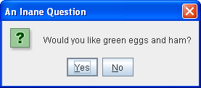
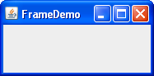

Jdialog JFrame

ii. Intermediate Containers
These are used to organize and group components within a top-level container.
- JPanel: A generic container used to group components. You can apply different Layout Managers to a JPanel to control how buttons and labels are positioned.
- JScrollPane: Provides scrollbars for a component when its content is too large to fit in the display area.
- JTabbedPane: Allows users to switch between different panels by clicking on tabs.
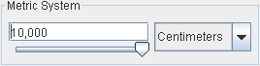


Jpanel JScrollPane

iii. Atomic Components
These are the "widgets" that the user actually interacts with. They cannot hold other components.
- JButton: A standard clickable button.
- JLabel: Used to display a short string of text or an image.
- JTextField: An input box for a single line of text.
- JCheckBox / JRadioButton: Used for selecting options from a list.
- JComboBox: A drop-down list of items.

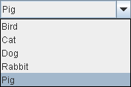

Jbutton JComboBox


JComboBox

2). a). JavaFX
JavaFX is a collection of classes and interfaces that defines Java’s modern graphical user interface (GUI). It can be used to create the types of GUIs demanded by rich client applications in the contemporary marketplace. JavaFX supplies a diverse set of controls, such as buttons, scroll panes, text fields, check boxes, trees, and tables, that can be tailored to fit nearly any application.
- With diagrams, explain the JavaFX
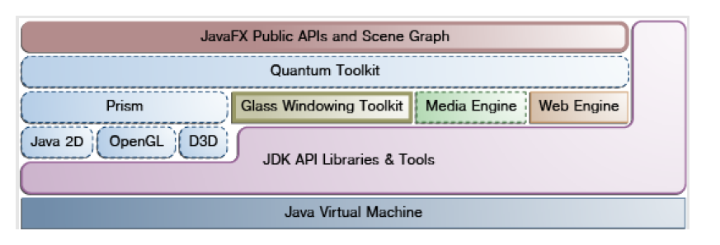
1. Java Virtual Machine (JVM)
The Java Virtual Machine is the foundation of JavaFX.
- Executes Java bytecode
- Provides platform independence (write once, run anywhere)
- Manages memory, garbage collection, and thread execution

2. JDK API Libraries & Tools
This layer contains standard Java Development Kit (JDK) libraries and tools.
- Provides core Java APIs (e.g., collections, I/O, networking)
- Includes development tools such as the compiler (javac) and debugger
- Supports integration between JavaFX and standard Java code
3. Prism
Prism is the high-performance graphics rendering engine in JavaFX.
- Handles 2D and 3D graphics rendering
- Optimizes graphics using hardware acceleration
Uses underlying graphics technologies:
- Java 2D – software-based rendering
- OpenGL – hardware-accelerated rendering
- Direct3D (D3D) – Windows-based hardware acceleration
4. Glass Windowing Toolkit
The Glass Toolkit provides low-level windowing and event-handling support.
- Manages windows, scenes, and native OS interaction
- Handles keyboard, mouse, and touch input events
- Interfaces directly with the operating system’s window manager
5. Media Engine
The Media Engine enables multimedia support in JavaFX applications.
- Plays audio and video files
- Supports streaming media
- Handles media formats such as MP3, MP4, and others
6. Web Engine
The Web Engine provides embedded web browsing capabilities.
- Renders HTML, CSS, and JavaScript content
- Enables embedding web pages inside JavaFX applications using WebView
7. Quantum Toolkit
The Quantum Toolkit is the core internal engine of JavaFX.
- Integrates Prism, Glass, Media Engine, and Web Engine
- Manages the rendering pipeline and event processing
- Coordinates communication between low-level components and public APIs
8. JavaFX Public APIs and Scene Graph
This is the topmost layer and the part developers interact with directly.
- Provides JavaFX classes such as Stage, Scene, Button, Label, and Pane
- Uses the Scene Graph, a hierarchical structure of UI components (nodes)

